**AWS Databases**

* For Relational Databases we have fully managed RDS
* For other Database Categories we have following services  
  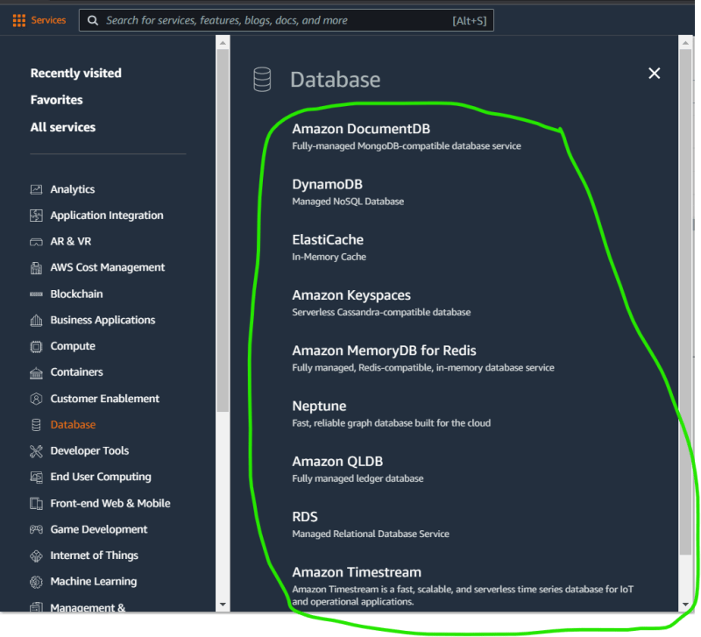
* Databases
  + NOSQL => Dynamo DB
  + Mongo DB => Document DB
  + Cassandra => KeySpaces
  + Memcahced => Elastic Cache
  + Redis => Elastic Cache
  + Graph => Neptue
  + Block Chain => QLDB
  + Time Series Databases => TimeStream
* Non-Relational Databases:
  + Categories:
    - Key/Value Stores
    - Document Oriented Stores
    - Graph Databases

**DynamoDB**

* This is NoSQL Database
* This is a managed non relational database that can handle thousands of reads and writes per second.
* It acheives this performance by spreading data into multiple partitions.
* A Partition is allocation of storage for table & its backed by SSD drives in Multiple AZs
* Partition and Hash Keys:
  + Here we create table and we must specify a primary key and a data type.
  + A Partition key (hash key) is a primary key that contains a single value
* Attributes and Items:
  + Each key/value pair composes of an attribute and one or more attributes make up an item.
* Create a dynamo db table  
  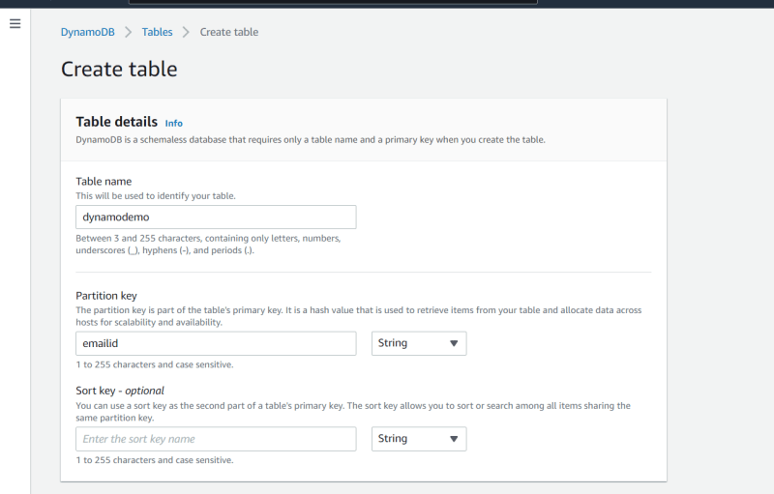  
  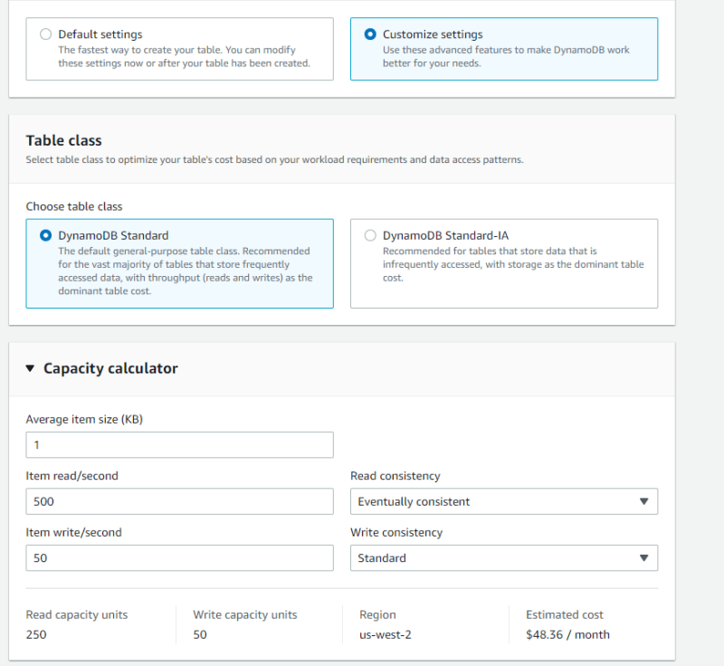  
  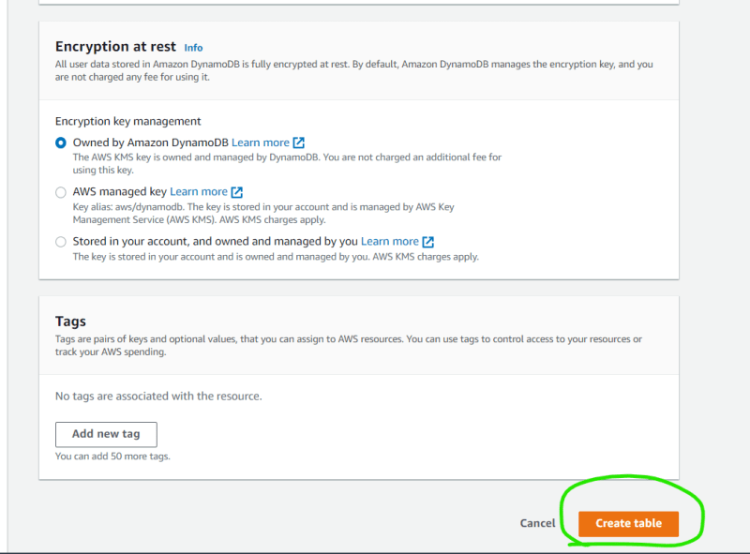  
  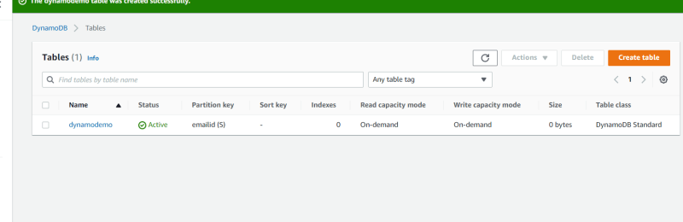
* Data is written into Dynamo db from applications i.e. code [Refer Here](https://docs.aws.amazon.com/amazondynamodb/latest/developerguide/Programming.SDKOverview.html)
* Performing Operations [Refer Here](https://docs.aws.amazon.com/amazondynamodb/latest/developerguide/GettingStarted.CreateTable.html)
* Connecting to table [Refer Here](https://docs.aws.amazon.com/amazondynamodb/latest/developerguide/Using.API.html)
* Backups:
* Replicas:  
  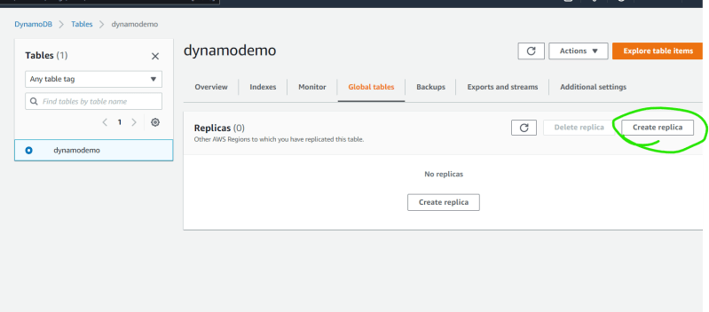  
  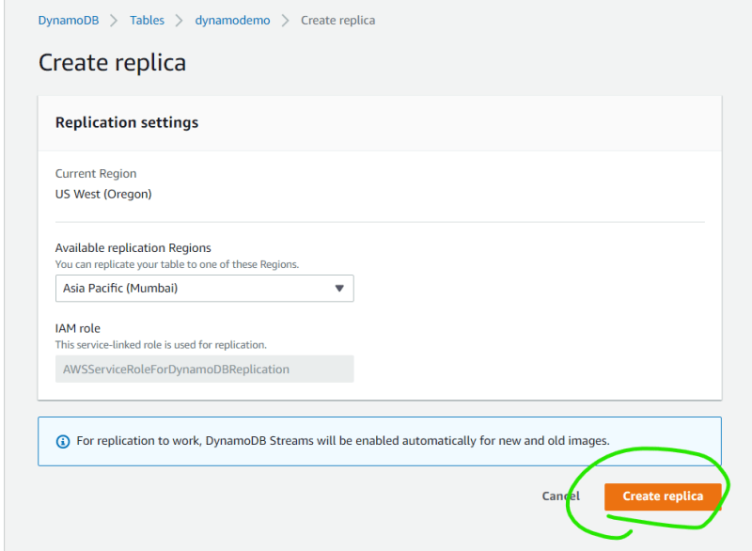
* Secondary Indexes solves issues with querying the dynamo db with items other than primary/partition key. When we create secondary index choose set of attributes which are called as projected attributes  
  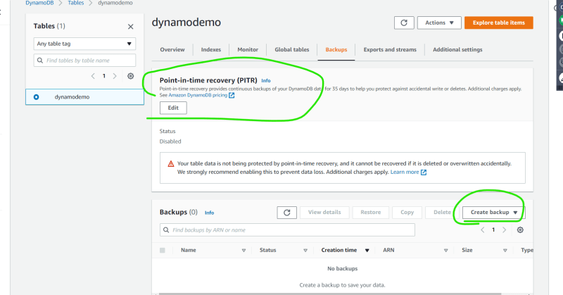
* Aws Dynamo DB Accelarator (DAX) is fully managed highly available in memory cache for Dynamo Db that delivers upto 10 times performance improvement
* Review the costs by price estimates